**c++ program to draw lines-dotted,thin,thick,dashed**

#include<iostream>

#include<math.h>

#include<graphics.h>

#define ROUND(a)((int)(a+0.5))

using namespace std;

class Line{

private:

int x1,y1,x2,y2;

public:

void accept();

void solid_line(int xa,int ya,int xb,int yb);

void dotted_line(int xa,int ya,int xb,int yb);

void dashed_line(int xa,int ya,int xb,int yb);

void call(int ch);

};

void Line::accept(){

cout<<"Enter starting and end points of line to be drawn:"<<endl;

cout<<"Enter x1: "<<endl;

cin>>x1;

cout<<"Enter y1: "<<endl;

cin>>y1;

cout<<"Enter x2: "<<endl;

cin>>x2;

cout<<"Enter y2: "<<endl;

cin>>y2;

}

void Line::solid_line(int xa,int ya,int xb,int yb){

int dx,dy,steps,k;

dx=xb-xa;

dy=yb-ya;

float x=xa,y=ya,xinc,yinc;

if(abs(dx)>abs(dy))

steps=abs(dx);

else

steps=abs(dy);

xinc=dx/(float)steps;

yinc=dy/(float)steps;

putpixel(ROUND(x),ROUND(y),2);

for(k=0;k<steps;k++){

x+=xinc;

y+=yinc;

putpixel(ROUND(x),ROUND(y),2);

delay(10);

}

}

void Line::dotted_line(int xa,int ya,int xb,int yb){

int dx,dy,steps,k;

dx=xb-xa;

dy=yb-ya;

float x=xa,y=ya,xinc,yinc;

if(abs(dx)>abs(dy))

steps=abs(dx);

else

steps=abs(dy);

xinc=dx/(float)steps;

yinc=dy/(float)steps;

putpixel(ROUND(x),ROUND(y),2);

for(k=0;k<steps;k++){

if(k%2==1){

putpixel(ROUND(x),ROUND(y),2);

delay(10);

}

x+=xinc;

y+=yinc;

}

}

void Line::dashed_line(int xa,int ya,int xb,int yb){

int dx,dy,steps,k;

dx=xb-xa;

dy=yb-ya;

float x=xa,y=ya,xinc,yinc;

if(abs(dx)>abs(dy))

steps=abs(dx);

else

steps=abs(dy);

xinc=dx/(float)steps;

yinc=dy/(float)steps;

putpixel(ROUND(x),ROUND(y),2);

for(k=0;k<steps;k++){

if(k%10<6){

putpixel(ROUND(x),ROUND(y),2);

delay(10);

}

x+=xinc;

y+=yinc;

}

}

void Line::call(int ch){

if(ch==1){

solid_line(x1,y1,x2,y2);

delay(100);

}

else if(ch==2){

dotted_line(x1,y1,x2,y2);

delay(100);

}

else if(ch==3){

dashed_line(x1,y1,x2,y2);

delay(100);

}

else{

cout<<"Error"

}

}

int main(){

cout<<"Enter the style of line to be drawn: \n1:solid\n2:dotted\n3:dashed\n "<<endl;

int ch;

cout<<"Enter Your Choice: "<<endl;

cin>>ch;

Line a;

a.accept();

int gd = DETECT, gm;

initgraph(&gd,&gm,NULL);

a.call(ch);

getch();

closegraph();

restorecrtmode();

return 0;

}

**Output:**

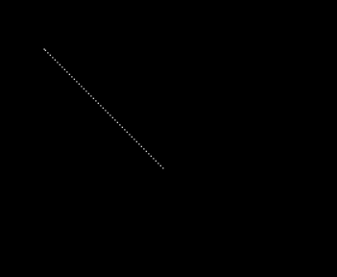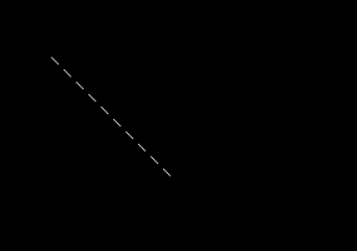**

**Output:**

